MGMT 670 – Business Analytics

Purdue University

Professor Alexander

Homework Exercises #1

1. Fizzer Inc., a large, multinational pharmaceutical company, is developing a new product aimed at reducing the pain associated with migraine headaches and two drugs are currently under development. One consideration in the evaluation of the medication is how long the pain-killing effects of the drugs last. A random sample of 12 tests for each drug revealed the following times (in minutes) until the effects of the drug were neutralized. The random samples are as follows:

|  |  |  |  |  |  |  |  |  |  |  |  |  |
| --- | --- | --- | --- | --- | --- | --- | --- | --- | --- | --- | --- | --- |
| Drug A | 258 | 214 | 243 | 227 | 235 | 222 | 240 | 245 | 245 | 234 | 243 | 211 |
| Drug B | 219 | 283 | 291 | 277 | 258 | 273 | 289 | 260 | 286 | 265 | 284 | 266 |

Questions:

1. Drug A mean = 234.75, standard deviation = 13.92

Drug B mean = 270.92, standard deviation = 19.90

1. Drug B appears to be more effective for a longer period.
2. Drug B appears to have greater variability in effect time.
3. Drug A Coefficient of Variation (CV) = 0.059309

Drug B Coefficient of Variation (CV) = 0.073461

Based on the coefficient of variation, Drug B has greater variability in its effect time.

1. StockWatcher, an up and coming financial firm, tracks the performance of many companies and publishes an evaluation of each. Along with a variety of financial data, StockWatcher includes a Fair Value estimate for the price that should be paid for a share of the company’s common stock. Data for 30 companies are available in the file named “Fair_Value.xlsx”. The data include the Fair Value estimate per share of common stock, the most recent price per share, and the earning per share for the company.

Questions:

1. The scatter diagram is on the next page.

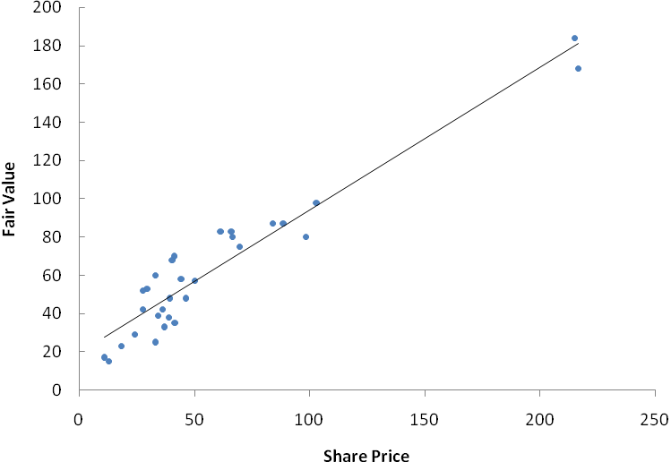

The sample correlation coefficient is .954. This indicates a strong positive linear relationship between StockWatcher’s Fair Value estimate per share and the most recent price per share for the stock.

1. The scatter diagram is shown below:

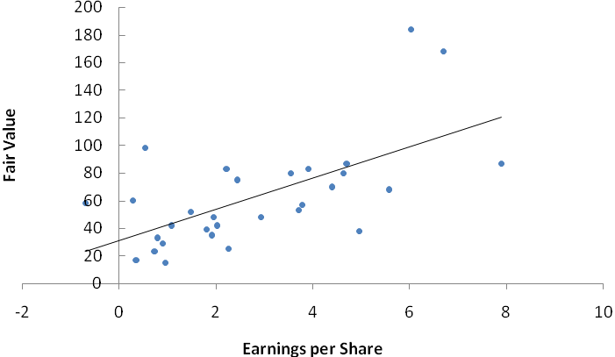

The sample correlation coefficient is .624. While not as strong of a relationship as shown in part a, this indicates a positive linear relationship between StockWatcher’s Fair Value estimate per share and the earnings per share for the stock.

1. The Environmental Protection Agency (EPA) tests all new cars and provides a mileage rating for both city and highway driving conditions. Thirty cars were tested and are contained in the data file “Automobiles”. The file contains data on several variables. In this problem, focus on the city and highway mileage data.

Questions:

1. City mean = 18.40, standard deviation = 2.95

Highway mean = 24.83, standard deviation 4.18

The data does appear to support the premise that cars get better mileage on the highway than around town. However, to check for statistical significance we should conduct a paired t-test, which we will discuss in Module 2.

1. City Coefficient of Variation (COV)= 0.160589

Highway Coefficient of Variation (COV) = 0.168234

Calculating the coefficient of variation indicates that highway driving has a slightly higher relative variability when compared to city driving.

1. Use the Empirical Rule:

2 standard deviations away from the mean (~95%)= 24.3096 ~ 24.833

At or above the mean (100%-95%)/2 = 2.5%

2.5% of the cars get at least as good mileage in city driving conditions as the mean mileage for highway driving for all cars.